SUBCOURSE EDITION
AV 0570 A

US ARMY AVIATION CENTER

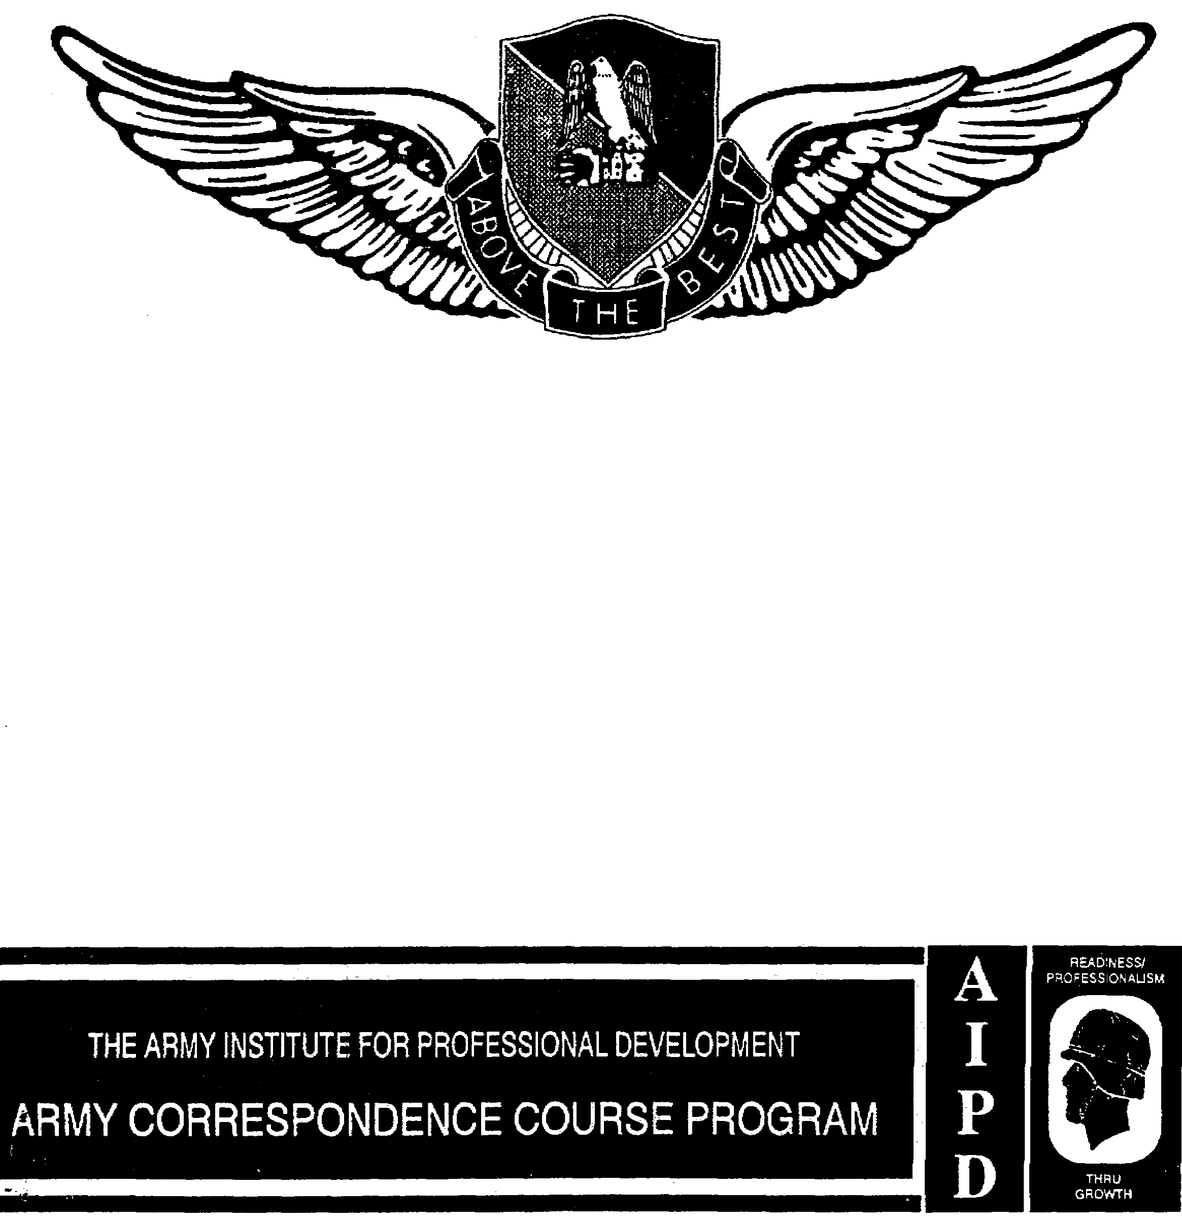

SHOP AND FLIGHT LINE SAFETY

THIS SUBCOURSE HAS BEEN REVIEWED FOR OPERATIONS SECURITY CONSIDERATION.

SHOP AND FLIGHT LINE SAFETY

Subcourse Number AV 0570

EDITION A

United States Army Aviation Center
Fort Rucker, Alabama 36362-5000

2 Credit Hours

Edition Date: September 1992

SUBCOURSE OVERVIEW

This subcourse reflects the safety standards and practices necessary for maintenance operations within the hangar, within allied shops, and on the flight line. All maintenance operations are governed by several general safety practices as well as the requirement for standard color coding of hazards. In addition, there exists special safety considerations peculiar to the individual activity within each maintenance area.

No prerequisites exist for this subcourse.

This subcourse reflects the current doctrine when it was prepared. In your own work, always refer to the latest publications.

Unless otherwise stated, the masculine gender of singular pronouns refers to both men and women.

TERMINAL LEARNING OBJECTIVE

ACTION: Conduct safety surveys within the hangar, within the allied shop areas, and on the flight line.

CONDITION: You may use the lesson text and references to complete the examination.

STANDARD: To prove competency of this task, you must achieve a minimum of 70 percent on the examination.

AV 0570

TABLE OF CONTENTS

Section Page

Lesson 1: SAFETY PRACTICES 1-1

Vehicles 1-2
Tools and Fire Extinguishers 1-2
Housekeeping 1-3
Horseplay 1-4

Practice Exercise 1-7

Answer Key and Feedback 1-8

Lesson 2: HANGAR SAFETY 2-1

Warning Signs and Hazard Markings 2-1
Fire Prevention Standards 2-3
Working Conditions 2-4
Aircraft In Hangar 2-4

Practice Exercise 2-6

Answer Key and Feedback 2-7

Lesson 3: ALLIED SHOP SAFETY 3-1

The Avionics Shop 3-1
The Battery Shop 3-2
The Electrical Shop 3-2
The Engine Shop 3-3
The Machine Shop 3-4
The Paint Shop 3-4
The Sheet Metal Shop 3-5
The Welding Shop 3-5

Practice Exercise 3-7

Answer Key and Feedback 3-9

Lesson 4: RAMP AND FLIGHT LINE SAFETY 4-1

Foreign Object Damage 4-2
Aircraft Parking 4-2

i AV 0570

Section Page

Support Equipment 4-3

Practice Exercise 4-5

Answer Key and Feedback 4-6

Lesson 5: MAINTENANCE OPERATIONS SAFETY 5-1

Ground Handling Aircraft 5-2
Aircraft Jacking 5-2
Aircraft Run-up 5-2
Aircraft Systems Servicing 5-4

Practice Exercise 5-7

Answer Key and Feedback 5-8

Appendix A: Survey Documents A-1

Appendix B: Publication Extracts B-1

Fire Extinguishers January 1985

Use the above publication extract to take this subcourse. This subcourse reflects current doctrine when the subcourse was prepared. In your own work, always refer to the latest publications.

ii AV 0570

LESSON 1

SAFETY PRACTICES

Critical Task: NA

OVERVIEW

LESSON DESCRIPTION:

This lesson covers the safety standards and practices necessary for maintenance operations. All maintenance operations are governed by several general safety practices. In addition, there exists special safety considerations peculiar to the individual activity within each maintenance area.

TERMINAL LEARNING OBJECTIVE:

ACTION: Conduct safety surveys within the hangar, within allied shop areas, and on the flight line.

CONDITION: You may use the lesson text to complete the action.

STANDARD: You will know the general safety practices, the proper color coding of common hazards, and the special hazards and safety practices necessary for each maintenance area within the shop and flight line environment.

REFERENCE: The material in this lesson was derived from the following publications: AR 385-30, AR 385-32, FM 10-68, and TM 55-1500-204-25/1.

INTRODUCTION

Every year thousands of soldiers are injured while working on a flight line, in a hangar, or in allied shop areas. Usually these injuries result from simple things such as running, slipping, falling, tripping, smoking where they should not, and failing to wear proper clothing or to use protective equipment. In addition to specific safety requirements for different shops and the flight line, there are several general safety practices that must be enforced regardless of where a person works.

1-1 AV 0570

1. VEHICLES

Before anyone is allowed to operate a piece of equipment, he must be properly trained and licensed for its operation. Include the following in your operating procedures for the safe operation of motor vehicles:

a. Enforce speed limits.

b. Regulate traffic directional flow if space will allow.

c. Use ground guides when backing vehicles with obstructed visibility to the rear or either side.

d. Do not move large vehicles, such as cranes, within any maintenance area without a ground guide.

2. TOOLS AND FIRE EXTINGUISHERS

All work areas have the need for tools and fire protection. Although the particular types of tools and extinguishers vary between work areas, there are general rules in selecting tools and extinguishers and how to use them.

a. Tools and Tool Boxes

Always use the proper tool for the job. Remember, a screwdriver is not a chisel or a pry bar.

(1) You must provide racks, shelves, or tool boxes for tools not in use to assure immediate accessibility and to eliminate the hazards created by misplaced or forgotten tools. You should never use tool boxes, packing cases, and barrels as workstands or ladders.

(2) You will inspect tools. Remove defective tools from service for repair or salvage. Store and carry tools with a sharp cutting edge in protective covers.

(3) Power tools will be equipped with guards, will have insulated wiring, will be grounded, and will have electrical contacts enclosed. When tools are used on ladders, scaffolds, platforms, or other elevations, observe special precautions to prevent them from being dropped or falling from these levels.

b. Fire Extinguishers

For the sake of simplicity, it has always been taught that you must have three things for a fire: heat, oxygen, and combustible material. If you eliminate one of these, such as cooling, smothering, or displacing the oxygen, the fire goes out.

1-2 AV 0570

However, we now know that there is a fourth element to a fire, a chemical chain reaction. Interrupting this chain reaction also results in extinguishing the fire.

(1) Extinguishing Agents

(a) Water (H₂O) extinguishes fire by cooling. Water is nontoxic and inexpensive.

(b) Carbon dioxide (CO₂) displaces oxygen from the fire, thereby smothering it. Although CO₂ leaves no residue and is relatively inexpensive, it has two disadvantages. First, it requires a 25 to 50 percent concentration to extinguish a fire. At levels above 10 percent, C0₂ creates a potential hazard; at concentrations above 15 percent, incapacitation and unconsciousness can result within one minute. Second, CO₂ has poor outdoor extinguishing effectiveness.

(c) Dry chemical agents operate on three primary principles: smothering, shielding (barrier between the flame and the combustible material), and chain-breaking reaction (inhibiting the chemical chain reaction). Dry chemical agents are non-toxic, but you should take care not to inhale large quantities because breathing problems may result. Some dry chemicals are corrosive and may cause additional damage to equipment by themselves.

(d) Halon is an alternative to CO₂ and dry chemical agents. Appendix B covers Halon in more detail.

(2) Extinguisher Classification

Every fire extinguisher is marked by numbers, one or more letters (A, B, C, or D), or both. The number designates the extinguisher's ability to put out a fire. This fire rating number will precede the letter classification, such as 4A80BC. The rating provides an idea of the fire size that can be extinguished. Letters identify suitability for use on a particular class of combustibles (Figure 1-1).

3. HOUSEKEEPING

a. Failure to establish and enforce good housekeeping practices is the most common cause of fires within the shop, hangar, and flight line environments. All flight line ramps, hangars, and shop floors must be kept free of--

(1) Tripping hazards (unattended tools and parts).

1-3 AV 0570

(2) Slipping hazards (oil, grease, and water on waxed surfaces).

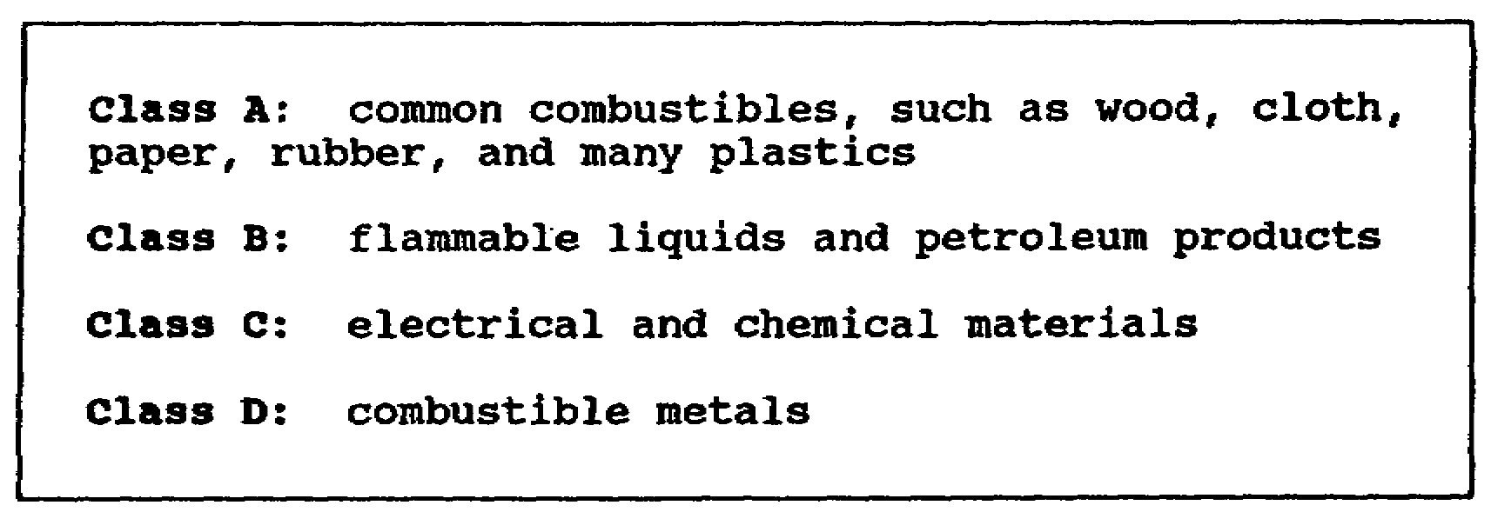

Figure 1-1. Classes of combustibles

(3) Fire hazards (piles of oily rags).

(4) Objects that would cause damage or injury if they were run over by, thrown by, or ingested into equipment or aircraft.

b. Organize areas to facilitate finding the desired tools or parts. Work areas should be clean.

c. You should use only authorized solvents and cleaning materials to clean parts, tools, hands, and fuel or oil spills. Never use gasoline as a solvent or cleaning agent.

d. Because of the great number of flammable materials, restrict smoking only to designated, authorized, and marked smoking areas. Smoking, however, will NOT be permitted within 50 feet of any storage area used for such things as fuel, paint, or other flammable substance. These storage areas and any other area within the shop and flight line environment where smoking is prohibited either by regulation or command directive will have NO SMOKING signs posted and enforced.

4. HORSEPLAY

Games, running, or practical jokes cannot be tolerated on the flight line, in the hangar, or in any allied shop area. Any person witnessing any of these activities will do one or more of the following:

a. Put an immediate stop to the activity, or report the activity to someone who has the authority to stop it.

1-4 AV 0570

b. After the activity is stopped, report it to the responsible supervisor who has the authority to prevent any future occurrence of the same or similar activity.

c. If necessary, report the incident to the unit commander for resolution.

1-5 AV 0570

LESSON 1

PRACTICE EXERCISES

The following items will test your grasp of the lesson material. Each item has only one correct answer. When you complete the exercise, check your answers with the answer key that follows. If you answer any item incorrectly, restudy that part of the lesson.

1. What is the most common cause of fires within the hangar, shop, and flight line environments?

A. poor housekeeping
B. welding activities
C. fuel and oil spills
D. faulty electrical equipment

2. Work areas should be kept clean and organized to

A. alert crew members of engine starts.
B. reduce horseplay and practical jokes.
C. facilitate finding desired tools or parts.
D. prevent smoking within 50 feet of flammable substances.

3. A class __________ fire extinguisher is designated to fight an electrical fire.

A. B
B. C
C. D
D. E

1-7 AV 0570

LESSON 1

PRACTICE EXERCISE

ANSWER KEY AND FEEDBACK

Item Correct Answer and Feedback

1. A. poor housekeeping

Welding activities, fuel and oil spills, and faulty electrical equipment can cause a fire, but all such fires result from poor housekeeping. (page 1-3, para 3a)

2. C. facilitate finding desired tools or parts.

Clean and organized work areas allow personnel to locate items quickly and reduce safety hazards that result from poor housekeeping. (page 1-4, para 3b)

3. B. C.

Only Class C fire extinguishers are designed to fight electrical and chemical fires. (page 1-4, Figure 1-1)

1-8 AV 0570

LESSON 2

HANGAR SAFETY

Critical Task: NA

OVERVIEW

LESSON DESCRIPTION:

This lesson covers the safety standards and practices necessary for maintenance operations within the hangar. All maintenance operations are governed by several general safety practices as well as the requirement for standard color coding of hazards. In addition, there exists special safety considerations peculiar to the individual activity within each maintenance area.

TERMINAL LEARNING OBJECTIVE:

ACTION: Conduct safety surveys within the hangar.

CONDITION: You may use the lesson text to complete the action.

STANDARD: You will know the general safety practices, the proper color coding of common hazards, and the special hazards and safety practices necessary for each maintenance area within the hanger.

REFERENCE: The material in this lesson was derived from the following publications: AR 385-30, AR 385-32, FM 10-68, and TM 55-1500-204-25/1.

INTRODUCTION

Of primary importance to hangar safety is the identification and proper making of fire safety equipment, structural items within the hangar, physical hazards, and areas where caution must be exercised. Additionally, hangar safety includes the availability and proper functioning of fire prevention equipment and the enforcement of policies concerning parking aircraft within the hangar and governing working conditions.

1. WARNING SIGNS AND HAZARD MARKINGS

Army Regulation 385-30 prescribes the signs and symbols to mark physical hazards and the types of hazards that will be

2-1 AV 0570

uniformly marked through the Army. It also requires that commanders at all levels will ensure all markings comply with prescribed color codes and symbols. These color codes and symbols give direction or identify inherent hazards, the purpose of items, and safety limitations.

a. Red Markings

This color identifies fire suppression equipment, fire exits, stop buttons or bars used for the emergency stopping of machinery or equipment, and containers of flammable liquids. If the area is large or if the fire extinguisher is not readily visible to area occupants, red will be used on the wall or support above the fire extinguisher to show its location.

EXCEPTIONS: Local law may provide for green fire exit signs.

Table of organization and equipment units may store petroleum products in containers painted olive drab with contents printed in yellow letters on the side.

Flammable liquid containers for waste fuel will be yellow with black letters and will show the contents.

b. Yellow or Yellow and Black Markings

These colors identify caution and physical hazard areas. Location and examples are in Figure 2-1.

c. Green Markings

This color designates safety equipment and devices (location of first aid, first aid equipment, and safety instruction signs).

d. Black and White Markings

These colors designate housekeeping and interior traffic (aisles through nonhazardous areas, locations of refuse cans, and floor areas that must be kept clear around first aid, fire fighting, or emergency).

e. Blue Markings

This color will be used on the outside of switch boxes and electrical controls that are the starting point or power source for hazardous electrical machinery and equipment.

2-2 AV 0570

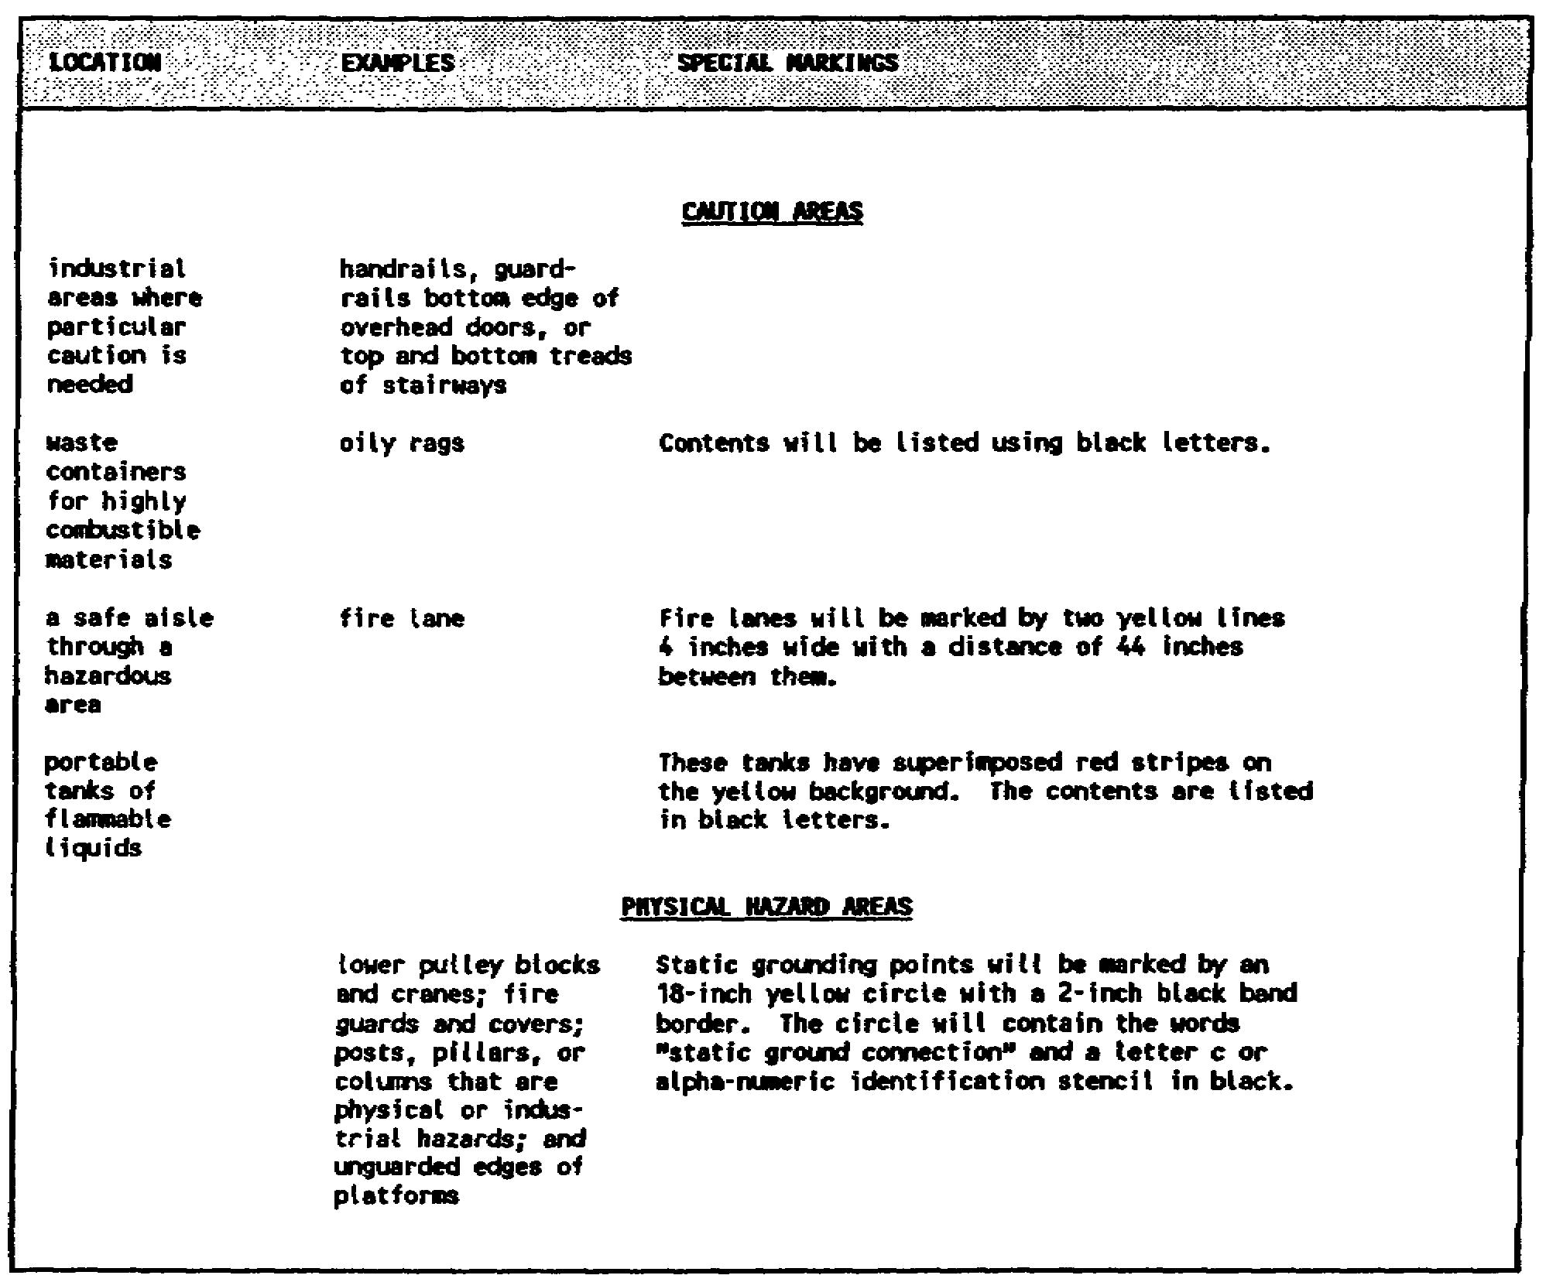

Figure 2-1. Yellow or yellow and black harked areas

f. Orange Markings

This color will be used as the basic color to designate dangerous parts of machines (electrical conduits that may cut, crush, shock, or injure).

2. FIRE PREVENTION STANDARDS

a. Fire extinguishers will be placed along normal paths of travel not to exceed 75 feet (50 feet for Class B) from the user. They must be inspected monthly and weight tested annually.

2-3 AV 0570

b. Fire lanes must be kept clear of obstructions at all times.

c. Fire exits will be unlocked when personnel are present in the structure. If installed, emergency bars and self-closing devices on doors will operate properly.

d. Volatile liquids used for washing and cleaning parts will not be left in open containers.

e. Self-closing containers will be used for disposal of oily rags.

f. Covered fire-resistant containers will be used for other types of trash.

g. Static grounding points will have a maximum resistance of 10,000 ohms. Grounding wires will be inspected monthly. The grounding system must be inspected annually and tested once every two years. A record will be kept for each grounding point and will include the date tested. The reading will be in ohms.

3. WORKING CONDITIONS

a. There must be sufficient light available to work under all conditions. Sufficient lighting can be achieved by using structurally installed lights, portable light systems, or both. If portable lights are used, they should produce a minimum light of 50 candlepower and have safety lenses installed to prevent shattering if dropped or knocked over.

b. Metal-cleated footgear should not be worn when climbing on aircraft because objects may get wedged in the cleats and become a source of foreign object damage. Do not climb or stand on any part of an aircraft except approved decks, platforms, or areas marked "step."

c. Do not work under any aircraft suspended from a hoist or on aircraft jacks unless the fuselage has been blocked.

d. All aircraft parts, cowlings, and covers that are removed from an aircraft must be tagged for serviceability and must be properly stored. Tools, when not in use, should be returned to their proper storage area. Never place tools or parts on ramps, ladders, or aircraft when they may fall and cause injury to people or damage to equipment.

4. AIRCRAFT IN HANGAR

When an aircraft is moved into the hangar for either maintenance or parking, you must ground the aircraft and disconnect the

2-4 AV 0570

battery. You also must chock the wheels of wheel-mounted aircraft and place a drip pan under the aircraft. Last, you should remove the ground handling wheels from skid-mounted aircraft.

2-5 AV 0570

LESSON 2

PRACTICE EXERCISE

The following items will test your grasp of the lesson material. Each item has only one correct answer. When you complete the exercise, check your answers with the answer key that follows. If you answer any item incorrectly, restudy that part of the lesson.

1. Static ground points will be marked by an 18-inch circle with a 2-inch black border. What is the required color of the 18-inch circle?

A. red
B. green
C. white
D. yellow

2. How often must fire extinguishers be weight tested?

A. monthly
B. annually
C. quarterly
D. semi-annually

3. A Class B fire extinguisher located on a normal path of travel must be within how many feet of its user?

A. 25
B. 50
C. 75
D. 100

4. The lower pulley block of a winch should be painted ________ and black.

A. red
B. white
C. orange
D. yellow

2-6 AV 0570

LESSON 2

PRACTICE EXERCISE

ANSWER KEY AND FEEDBACK

Item Correct Answer and Feedback

1. D yellow

Since the protrusion of the grounding rod represents a physical hazard, it is marked with yellow or yellow and black paint. (page 2-3, Figure 2-1)

2. B. annually

According to AR 420-90, fire extinguishers will be physically inspected monthly for proper charge and damage and will be weight tested annually. (page 2-4, para 2a)

3. B. 50

According to AR 420-90, fire extinguishers will be placed along the normal paths of travel not to exceed 75 feet (50 feet for Class B) from the user. (page 2-4, para 2a)

4. D. yellow

Since the lower pulley block of a winch represents a potential physical hazard, it is painted yellow or yellow and black. (page 2-3, Figure 2-1)

2-7 AV 0570

LESSON 3

ALLIED SHOP SAFETY

Critical Task: NA

OVERVIEW

LESSON DESCRIPTION:

This lesson covers the safety standards and practices necessary for maintenance operations within allied shops. All maintenance operations are governed by several general safety practices as well as the requirement for standard color coding of hazards. In addition, there exists special safety considerations peculiar to the individual activity within each maintenance area.

TERMINAL LEARNING OBJECTIVE:

ACTION: Conduct safety surveys within allied shop areas.

CONDITION: You will use the lesson text to complete the action.

STANDARD: You will know the general safety practices, the proper color coding of common hazards, and the special hazards and safety practices necessary for each maintenance area within the shop and flight line environment.

REFERENCE: The material in this lesson was derived from the following publications: AR 385-30, AR 385-32, FM 10-68, and TM 55-1500-204-25/1.

INTRODUCTION

Allied shops are the leading source of accidents in the hangar environment. In addition to general safety practices and hangar safety marking and warning requirements, each allied shop has special safety requirements based on its functions.

1. THE AVIONICS SHOP

In addition to guarding against the hazards of electric shock, electrical fire, and toxic fumes from solder, avionics shops must have temperature and humidity control. The reason for temperature and humidity control is that these factors affect the

3-1 AV 0570

calibration accuracy of test equipment used to safety check aircraft systems. Maximum humidity is 50 percent, and maximum temperature is 77 degrees Fahrenheit.

a. Appropriate danger and warning signs will be posted, and electrical outlets will be properly color coded.

b. Electrical connections and outlets will use low-resistance grounds, and the connections will be protected from damage.

c. Proper ventilation will be provided during soldering operations.

d. Personal items, such as watches and rings, will NOT be worn while working in the shop.

e. A Class C fire extinguisher will be available within the shop.

2. THE BATTERY SHOP

a. Battery shops have a potential for burns, toxic fumes, chemical fires, and explosions because of the use of acids. To protect against burns, personnel working with batteries must wear special equipment (aprons, goggles, rubber gloves, or a combination of these items). They also are prohibited from wearing personal jewelry (watches or rings). In case of accident or battery acid spillage, slacked (hydrated) lime must be available to neutralize the acid. Areas made slippery by acid may be adequately neutralized with soda or alkaline solutions and washed with water. Finally, shower and eyewash facilities and equipment must be located within 25 feet of a battery work site.

b. Since some acid fumes have toxic, corrosive, or asphyxiating actions or if lead acid and nickel-cadmium are accidentally mixed, they will produce a flammable and possibly explosive vapor. Battery shops must have an adequate arc-proof ventilation system. Additionally, a respirator should be readily available.

c. Class C fire extinguishers must be available within the shop in case of fire. All lights and electric switches must be arc proof to reduce the chance of fire.

3. THE ELECTRICAL SHOP

a. Electrical shops present electric shock and electrical fire hazards. Color and identification of various wiring schemes are important in electrical maintenance safety. They are defined in Department of the Navy Military Standard (MIL STD) 1857(EL) and in MTL STD 686A.

3-2 AV 0570

b. To reduce the chance of accidental electrical shock, personal items (rings, watches, and dog tags) will not be worn by people working in the electrical shop. A safety equipment board will be present in the shop and contain safety equipment, such as poles, needed to extricate a person from the shock source.

c. To reduce the chance of an electrical fire, workbenches and wooden floors will be covered by rubber or felt. Any additional electrical outlets (whether on the floor, bench, or wall) will be inspected for compliance with National Fire Code 410-52d. Class C fire extinguishers will be used to fight electrical fires.

4. THE ENGINE SHOP

Engine shops have several hazards. The hazards include noise, toxic fumes, and petroleum fires.

a. Hearing protection must be available and used by engine shop workers when the noise level exceeds 85 decibels.

b. Ventilation must be provided to remove exhaust fumes.

c. Engine stands will be inspected and properly maintained according to proper technical manuals.

d. Tool accountability will be strictly enforced to reduce the chance of foreign object damage.

e. Drip pans will be used for oil leaks, and floors will be kept free of oil.

f. Lights and electrical switches must be arc proof.

g. Class B fire extinguishers must be available for use in case of a fuel fire.

5. THE MACHINE SHOP

a. Machine-shops present hazards to sight, hearing, and unprotected parts of the body. Therefore, appropriate danger, warning, and caution signs will be posted, electrical outlets will be properly marked, and all equipment will be properly color coded.

b. All machines will have required protective guards installed. The guards should be inspected to ensure they are serviceable before operation.

3-3 AV 0570

c. Protective clothing will be available and used to include--

(1) Hand protection (gloves).

(2) Body protection (aprons).

(3) Hearing protection (earplugs or earmuffs).

(4) Foot protection (boots or protective shoes).

(5) Eye and face protection (goggles or face shield).

6. THE PAINT SHOP

Paint shops are known for being extreme fire hazards. They have a potential for toxic fumes and require the use of liquids that may irritate eyes or skin on contact.

a. Appropriate danger, warning, or caution signs must be posted. Electrical outlets must be color coded.

b. Adequate ventilation, either a water curtain or a paper fiber filter system, should be installed.

c. All lights and electrical switches must be arc proof.

d. Only the quantity of paint required for one work shift may be stored in the paint shop. Paint stored in the paint shop must be kept in a flammable storage locker made of at least 18-gauge material.

e. A Class B fire extinguisher must be available.

f. Protective clothing and equipment must be available and used to include--

(1) Eye protection (goggles).

(2) Hand protection (gloves).

(3) Lung protection (respirator).

(4) Body protection (apron or coveralls and fire blankets).

7. THE SHEET METAL SHOP

Sheet metal shops present a hazard of person injury. This injury can be due to noise level, use of machinery, and the need to handle sharp edges when working with metal.

3-4 AV 0570

a. Appropriate caution, warning, and danger signs will be posted; and electrical outlets will be color coded.

b. Machine hazards must be marked with proper color markings.

c. Scrap metal will be stored or properly disposed of to prevent accidental injury.

d. Protective clothing and equipment will be available and used to include--

(1) Eye protection (goggles).

(2) Hand protection (gloves).

(3) Body protection (aprons).

(4) Foot protection (safety shoes or boots).

(5) Hearing protection (earplugs or earmuffs).

8. THE WELDING SHOP

Welding shops present fire hazards because of the use of open flames and electric arcs. The heat they generate presents a burn hazard. The intensity of light presents an unfiltered viewing hazard. The use of pressurized, flammable gases presents an explosion hazard.

a. Appropriate warning, caution, and danger signs must be posted.

b. Ventilation should be provided by a push-pull type ventilation system.

c. Welding will not be permitted near flammable or explosive substances.

d. The welding site will be free of flammable material, or fire resistant shields must be installed between the welding site and any flammable material in the welding shop.

e. Welding is prohibited anywhere liquids and gases create an explosion hazard.

f. Fire guards with proper fire control equipment will be used during all welding operations. Maintain a fire watch for 30 minutes after the welding is completed.

3-5 AV 0570

g. The maximum operating pressure for acetylene will be 15 pounds per square inch.

h. The T-wrench used to adjust acetylene pressure will be left in place on the bottle when the bottle is being used.

i. Oxygen and acetylene bottles will be free of grease, capped when not in use, and marked according to MIL STD 101A.

j. The following protective clothing and equipment will be available and used during welding operations:

(1) Welder's apron.

(2) Safety shoes or boots.

(3) Protective sleeves and welder's gloves.

(4) Face shield, colored lenses (eye protection), or both.

(5) Adequate screens to shield the welding site from personnel not involved in the welding operation.

3-6 AV 0570

LESSON 3

PRACTICE EXERCIE8

The following items will test your grasp of the lesson material. Each item has only one correct answer. When you complete the exercise, check your answers with the answer key that follows. If you answer any item incorrectly, restudy that part of the lesson.

1. What material may be used to cover workbenches in the electrical shop?

A. felt
B. cork
C. leather
D. plastic

2. Why are maximums of 50-percent humidity and 77°F temperature required in an avionics shop?

A. to ensure no adverse affect on internal radio parts
B. to ensure the calibration accuracy of the test equipment
C. to comply with general aircraft maintenance manual standards
D. to reduce the fatigue of personnel working on sensitive radio equipment

3. What is the maximum operating pressure (in pounds per square inch) of an acetylene torch?

A. 10
B. 15
C. 20
D. 25

4. What protective equipment combination listed below must be used by a person painting?

A. goggles, gloves, and an apron
B. goggles, gloves, and earplugs
C. goggles, earplugs, and an apron
D. earplugs, gloves, an apron, and a respirator or mask (nose or mouth only)

3-7 AV 0570

5. What must you do when working on an engine that has been removed from the aircraft?

A. wear goggles
B. wear an apron
C. wear protective shoes
D. place a drip pan under the engine

3-8 AV 0570

LESSON 3

PRACTICE EXERCISE

ANSWER KEY AND FEEDBACK

Item Correct Answer and Feedback

1. A. felt

To reduce the chances of an electrical fire, work-benches and wooden floors will be covered by rubber or felt. Cork, leather, and plastic may not provide enough isolation from electrical hazards. Additionally, plastics produce toxic fumes when exposed to excessive heat or flames. Cork and leather tend to absorb liquids that may reduce their insulating value or present a fire hazard if they absorb petroleum products. (page 3-3, para 3c)

2. B. to ensure the calibration accuracy of test equipment

Temperature and humidity affect the calibration accuracy of test equipment used to safety check aircraft systems. (page 3-2, para 1)

3. B. 15

The maximum operating pressure for acetylene is 15 pounds per square inch. (page 3-6, para 8g)

4. A. goggles, gloves, and apron

Answers, B, C, and D include the use of earplugs that are not part of the required protective clothing and equipment for painting. (page 3-4, para 6f(2) thru (4))

3-9 AV 0570

5. D. place a drip pan under the engine

Goggles, apron, and protective shoes are items that personnel should wear when performing ALL potentially hazardous tasks. Placing the drip pan under the engine, however, is the only action that personnel must specifically do when working on an engine. (page 3-3, para 4e)

3-10 AV 0570

LESSON 4

RAMP AND FLIGHT LINE SAFETY

Critical Task: NA

OVERVIEW

LESSON DESCRIPTION:

This lesson covers the safety standards and practices necessary for maintenance operations on the flight line. All maintenance operations are governed by several general safety practices as well as the requirement for standard color coding of hazards. In addition, there exists special safety considerations peculiar to the individual activity within each maintenance area.

TERMINAL LEARNING OBJECTIVE:

ACTION: Conduct safety surveys on the flight line.

CONDITION: You may use the lesson text to complete the action.

STANDARD: You will know the general safety practices, the proper color coding of common hazards, and the special hazards and safety practices necessary for each maintenance area within the shop and flight line environment.

REFERENCE: The material in this lesson was derived from the following publications: AR 385-30, AR 385-32, FM 10-68, and TM 55-1500-204-25/1.

INTRODUCTION

The ramp and flight line environment is the most common source of foreign object damage (FOD) during maintenance operations. This environment also contains a potential for personal injury and damage to equipment due to the nature of activities that are required to be conducted on a maintenance ramp.

4-1 AV 0570

1. FOREIGN OBJECT DAMAGE

Army Regulation 385-95 defines FOD as--

. . . damage to or malfunction of an aircraft caused by an object that is alien to an area or system or is ingested by or lodged in a mechanism of an aircraft. FOD may cause material damage or it may cause a system or equipment to be unusable, unsafe, or less effective as in the case of fuel contamination.

a. The unit commander will ensure that FOD receptacles (yellow with black letters) are readily available through the flight line and ramp areas. The unit commander will ensure that ramp and flight line areas are subject to frequent "police call." If the flight line or ramp is covered by grass, he also will ensure it is kept mowed short and clippings are removed to reduce the chance FOD will be hidden.

b. The unit, section, or detachment will designate, in writing, an FOD prevention officer. The FOD officer will delegate areas of responsibility to specific unit personnel and will conduct frequent inspections to ensure the FOD program is viable and working.

c. All personnel will take an active role in FOD prevention. Common tasks include those listed in Figure 4-1.

2. AIRCRAFT PARKING

a. Do not park or moor aircraft closer than one wing or rotor span laterally to another aircraft. Allow sufficient slack in mooring straps to prevent stress on ropes ground fillings, mooring devices, or aircraft structure due to tire or strut inflation or wet rope shrinkage. If possible, part aircraft facing in a direction that will reduce transparent surfaces from being in the direct rays of the sun.

b. Aircraft moored for storage will be parked at least 750 feet from the center of the nearest taxiway. Adequate clearance also must be provided for maintenance, servicing, and fire lanes.

c. Fifty-pound CO₂ or equivalent halon extinguishers will be vailable as required by the facility preaccident and crash rescue
plans.

d. Place chocks fore and aft of main landing gear wheels or remove ground handling wheels. Do not use parking brakes as a

4-2 AV 0570

substitute for chocks. Use steel chocks for snow or ice conditions only. Use sandbags on flight lines or ramps made of steel matting. Use wooden chocks under all other conditions.

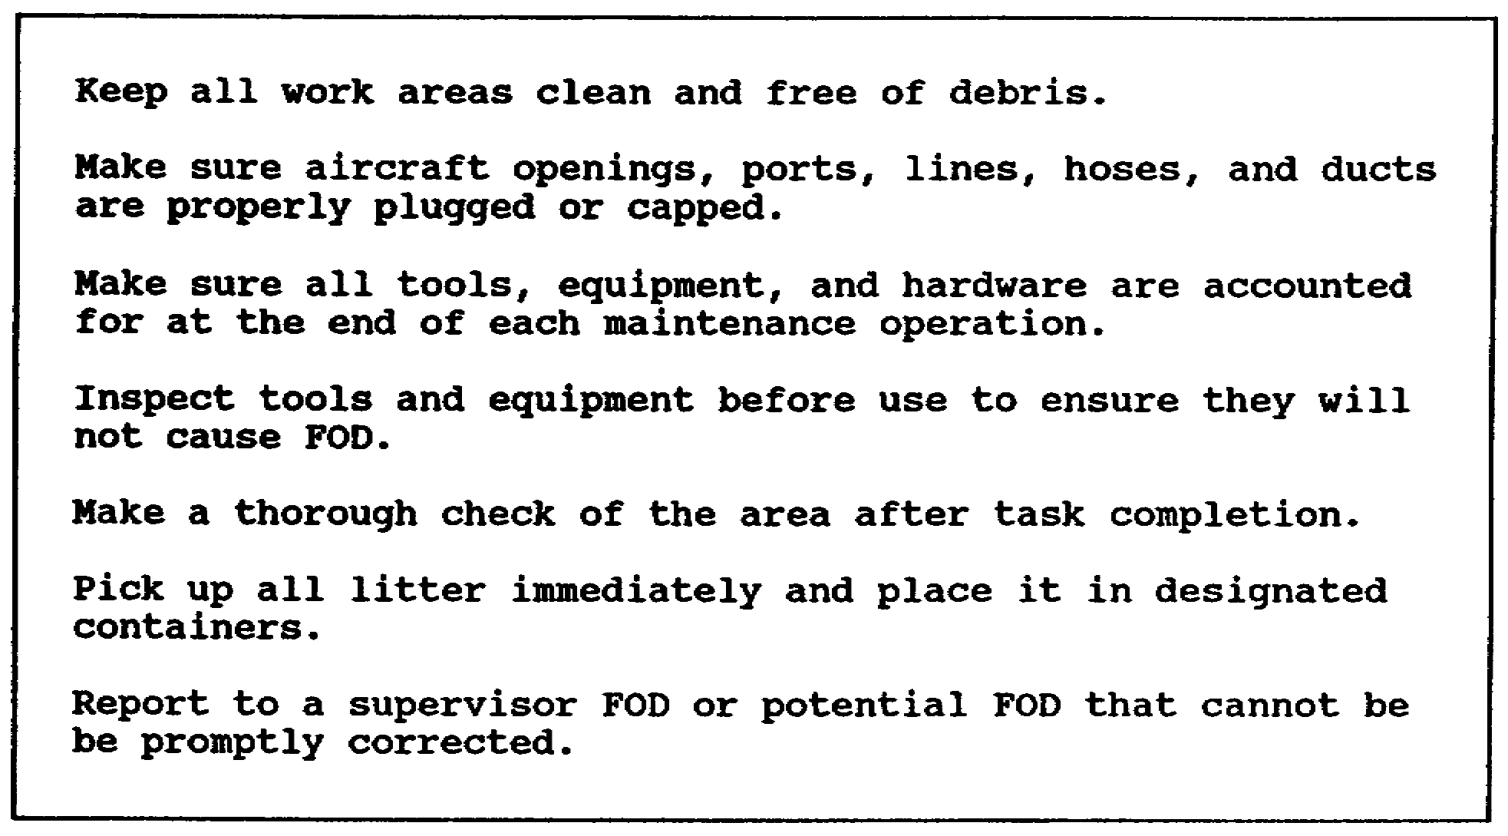

Figure 4-1. Common POD prevention tasks

e. Install gear and safety locking devices (required by operator's manual). Disconnect the battery. Ground the aircraft and use drip pans.

3. SUPPORT EQUIPMENT

a. All support equipment should be centrally located with ground support equipment (auxiliary power unit, ground power unit, and ramps), be painted yellow (table of distribution and allowances (TDA) units), or be painted green (TOE units). White reflective tape should be used on ground support equipment to prevent accidents during night taxi operations.

b. Support equipment will be inspected before use to determine serviceability according to applicable operator's manuals. Support equipment also should be used only to accomplish the functions it was designed to perform.

EXAMPLE: Using an auxiliary power unit as a maintenance ramp.

4-3 AV 0570

LESSON 4

PRACTICE EXERCISE

The following items will test your grasp of the lesson material. Each item has only one correct answer. When you complete the exercise, check your answers with the answer key that follows. If you answer any item incorrectly, restudy that part of the lesson.

1. What type of chocks should be used for aircraft (wheel landing gear) parked on steel matting?

A. wood
B. steel
C. aluminum
D. sandbags

2. What color should TOE authorized ground power units be painted?

A. green
B. black
C. yellow
D. orange

3. Slack should be left in ropes used to moor aircraft

A. to facilitate equal tension.
B. to allow shrinkage of ropes when wet.
C. to allow drainage of static electricity
D. to allow movement of aircraft in high winds.

4-5 AV 0570

LESSON 4

PRACTICE EXERCISE

ANSWER KEY AND FEEDBACK

Item Correct Answer and Feedback

1. D. sandbags

Sandbags provide better security on this surface than other types of blocking material. Use steel chocks for snow or ice conditions only. Use wooden blocks under all other conditions. (page 4-2, para 2d)

2. A. green

All TOE authorized equipment should be painted green. However, this doesn't exclude TDA deployable equipment or equipment on loan from the installation from being green as well. This will depend on local command directives. (Some forward deployed units may require that all equipment be painted green or sand.) (page 4-3, para 3a)

3. B. to allow shrinkage of ropes when wet.

Sufficient slack in mooring straps should be allowed to prevent stress on rope ground fillings, mooring devices, or aircraft structure due to tire or strut inflation or wet rope shrinkage. (page 4-2, para 2a)

4-6 AV 0570

LESSON 5

MAINTENANCE OPERATIONS SAFETY

Critical Task: NA

OVERVIEW

LESSON DESCRIPTION:

This lesson covers the safety standards and practices necessary for maintenance operations within the hangar, within allied shops, and on the flight line. All maintenance operations are governed by several general safety practices as well as the requirement for standard color coding of hazards. In addition, there exists special safety considerations peculiar to the individual activity within each maintenance area.

TERMINAL LEARNING OBJECTIVE:

ACTION: Conduct safety surveys within the hangar, within the allied shop areas, and on the flight line.

CONDITION: You may use the lesson text to complete the action.

STANDARD: You will know the general safety practices, the proper color coding of common hazards, and the special hazards and safety practices necessary for each maintenance area within the shop and flight line environment.

REFERENCE: The material in this lesson was derived from the following publications: AR 385-30, AR 385-32, FM 10-68, and TM 55-1500-204-25/1.

INTRODUCTION

The activities detailed in this section, except aircraft run-up that is confined to the flight line, can be conducted either in the hanger or on the flight line. The safety practices for these activities are supplementary to the safety policies and practices required by the area where they are conducted. They are not meant to replace area requirements.

5-1 AV 0570

1. GROUND HANDLING AIRCRAFT

Unlike other maintenance activities, there is no special skill qualification for personnel taking part in the ground handling of aircraft. Therefore, the supervisor or person responsible responsible for the movement must ensure--

a. All ground support, ground servicing, and maintenance equipment not required for aircraft movement are disconnected and moved clear of the aircraft. All lines, bars, attachments, and if required, ground handling wheels are of sufficient capacity, serviceable, and properly secured to the designated aircraft fittings, and to the designated fittings of the tow vehicle.

b. Ground crew members are assigned to operate the brakes of the aircraft that have them from the time the chocks are removed until they are replaced. These crew members stand near the tip of each wing of the forward tip of the main rotor to act as guides during movement. They direct the departure from and the approach to parking positions. A flashlight or luminescent wand should be used to signal instructions at night.

c. Before aircraft movement, all personnel should be told that movement speed will not exceed five miles per hour and that sudden starts or stops should be avoided. Personnel also should be told that extra precautions must be taken for movement over ice, snow, and rough or muddy ground.

d. During movement, never allow any person to sit, stand, or lay on the external portion of the aircraft or to jump from or aboard the tow vehicle or the aircraft being moved. Never allow the aircraft to be moved within 200 feet of the rear of an operating, turbine-powered aircraft or within 100 feet of other operating aircraft. Also, never allow the aircraft to be moved within 50 feet of any oil, fuel, or water-alcohol servicing operation or oil and fuel spills that have not been cleaned up.

2. AIRCRAFT JACKING

Aircraft jacking should be done only by skill-qualified maintenance personnel. The procedures in Figure 5-1 apply for all jacking operations.

3. AIRCRAFT RUN-UP

An operational check requires an aircraft to be started, run up, and tested. This type of run-up can only be done by aviators designated by the unit commander.

5-2 AV 0570

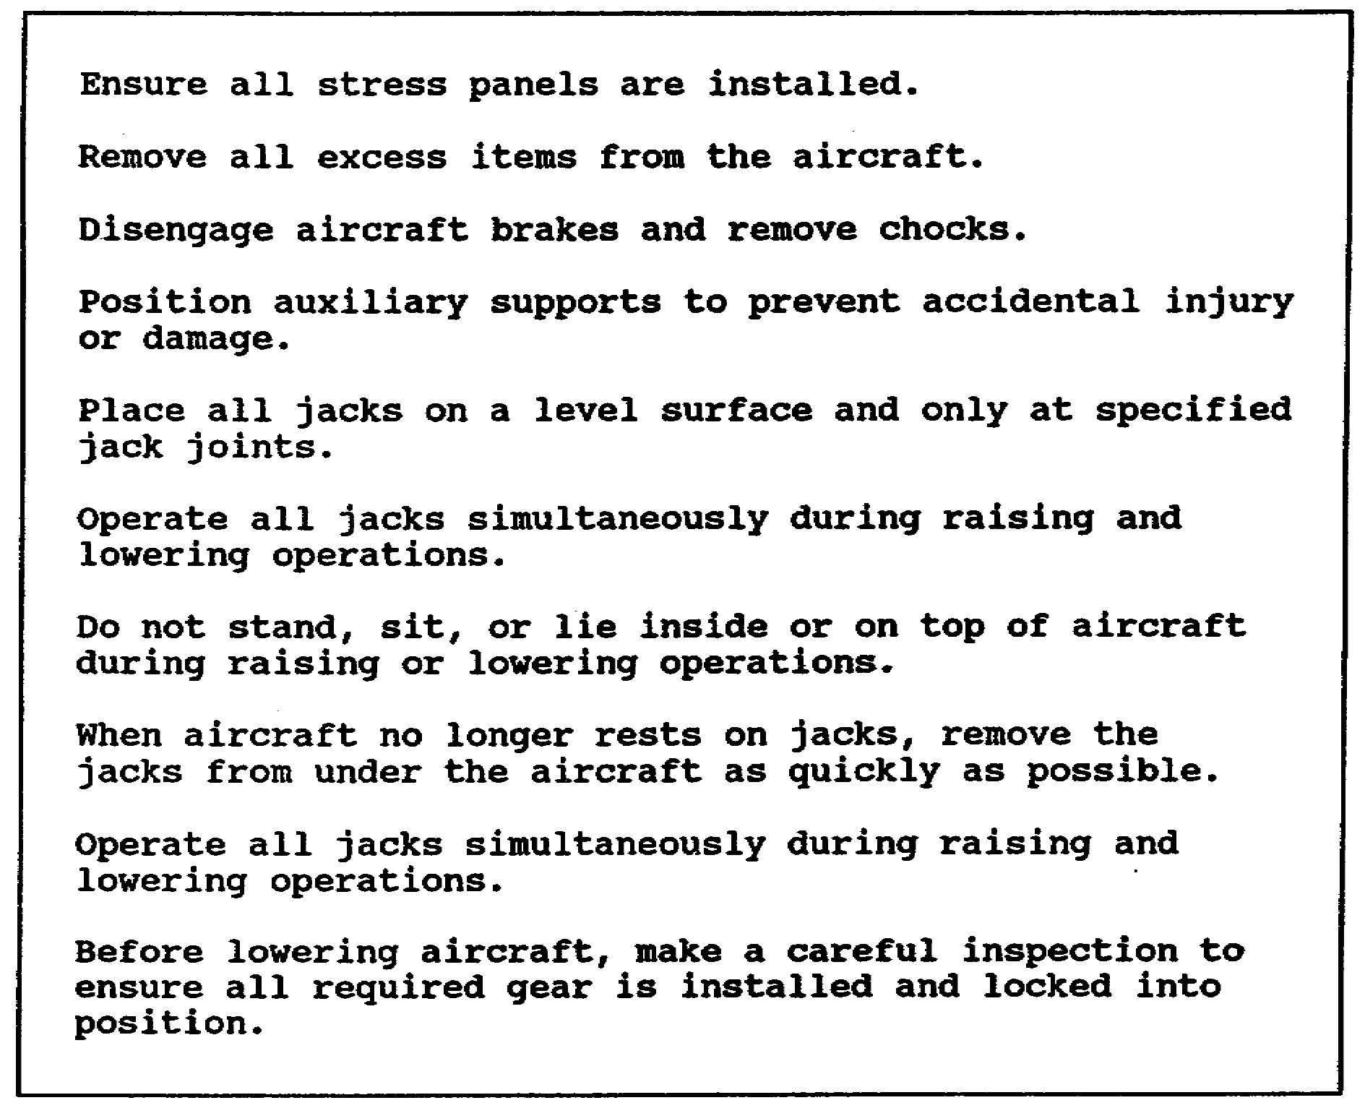

Figure 5-1. Jacking operations procedures

a. Before Engine Operation

The aircraft must be positioned to direct the exhaust away from occupied areas. Wings or rotor blades and surrounding areas must be clear of tools, rags, and covers. In addition, workstands and mooring ropes will be removed and secured. Access doors must be secured. Personnel must not be allowed on any external portion of the aircraft. A crew member must be stationed alert others of the engine start.

b. During Operation

If a crew member needs to approach the aircraft, he must first inform the pilot of his intention to approach. Next, he must allow clearance for rotors, for propellers, and for the effects of inlet suction and exhaust blast. Finally, he will not

5-3 AV 0570

wear loose-fitting clothing or carry loose items (rags, small tools, or cigarettes) in pockets when working on the aircraft.

c. After Operation

During the engine cooling period, all personnel will remain clear of the power plant exhaust system. If it is necessary to handle any portion of the power plant, asbestos gloves will be worn and precautions taken to prevent burning unprotected parts of the body. A crew member should be stationed to keep personnel clear of the power plant until it is cooled.

4. AIRCRAFT SYSTEMS SERVICING

a. Hydraulic Fluid

While servicing with hydraulic fluid, do not overfill the reservoir. If fluid is spilled, absorb it with clean rags. When filling reservoirs, ensure no dirt or foreign matter is allowed to enter the system.

b. Pneumatic

During pneumatic servicing, use only hoses of known origin or compressed air cylinders. Never use pressurized oxygen. Ensure the locking mechanism on the aircraft valve is engaged before installing the hose on the valve stem. Fill the system slowly to reduce heat generated by filling too rapidly. Do not overcharge the system.

c. Oxygen

Oxygen servicing requires the utmost in precautionary measures due to the highly explosive and flammable characteristics of oxygen. Only qualified personnel will be authorized to operate an oxygen servicing system.

(1) Aircraft will not be serviced with oxygen if any of the following exists:

(a) Aircraft electrical switches are ON.

(b) Ground powered equipment is operating within 50 feet of the service area.

(c) Aircraft is being serviced with oil, fuel, or anti-icing fluids.

(d) Any combustible fluids or materials are evident around the oxygen servicing equipment.

5-4 AV 0570

(2) Oxygen equipment will be kept clean and free of oil, grease, and moisture at all times.

(3) Personnel will be stationed at the servicing unit at all times during its operation. They are required to monitor system gauges and to shut all valves immediately on command.

5-5 AV 0570

LESSON 5

PRACTICE EXERCISE

The following items will test your grasp of the lesson material. Each item has only one correct answer. When you complete the exercise, check your answers with the answer key that follows. If you answer any item incorrectly, restudy that part of the lesson.

1. During hydraulic system service, hydraulic fluid is spilled on an aircraft deck. What corrective action should be taken?

A. Cover the spill with foam.
B. Wash the deck with solvent.
C. Absorb the fluid with clean rags.
D. Use a cleaning compound to absorb the spilled fluid.

2. After completing an aircraft jacking operation,

A. ensure all stress panels are installed.
B. remove the jacks as quickly as possible.
C. ensure ground handling equipment is properly installed.
D. inspect the aircraft to ensure all required gear is locked into position.

3. What is the minimum distance (in feet) between an aircraft being ground handled and the rear of an operating turbine engine?

A. 100
B. 200
C. 300
D. 400

5-7 AV 0570

LESSON 5

PRACTICE EXERCISE

ANSWER KEY AND FEEDBACK

Item Correct Answer and Feedback

1. C. Absorb the fluid with clean rags.

Hydraulic fluid is corrosive to some aircraft materials. Paints and excessive spills should be absorbed with clean rags. (page 5-4, para 4a)

2. B. remove the jacks as quickly as possible.

When the aircraft no longer rests on jacks, remove the jacks from under the aircraft as quickly as possible. This action will prevent damage to the aircraft if it suddenly settles due to unrelieved tension in wheel struts or skids. After removing the jacks, personnel should carefully rock the aircraft to relieve any tension before refueling or working under the aircraft. (page 5-2, Figure 5-1)

3. B. 200

During ground movement, never allow the towed aircraft to be moved to within 200 feet to the rear of an operating turbine powered aircraft or within 100 feet of any other type of operating aircraft. This will prevent loss of control due to high wind and will reduce risk to personnel from any airborne objects picked up in this wind. (page 5-2, para 1d)

5-8 AV 0570

